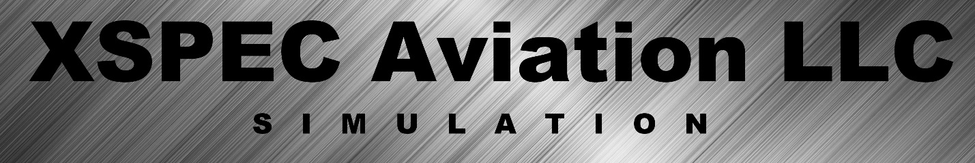
2017 Information Pamphlet
www.xspecaviation.com
XSPEC Aviation is the leader in providing affordable; effective flight simulators since 2012.
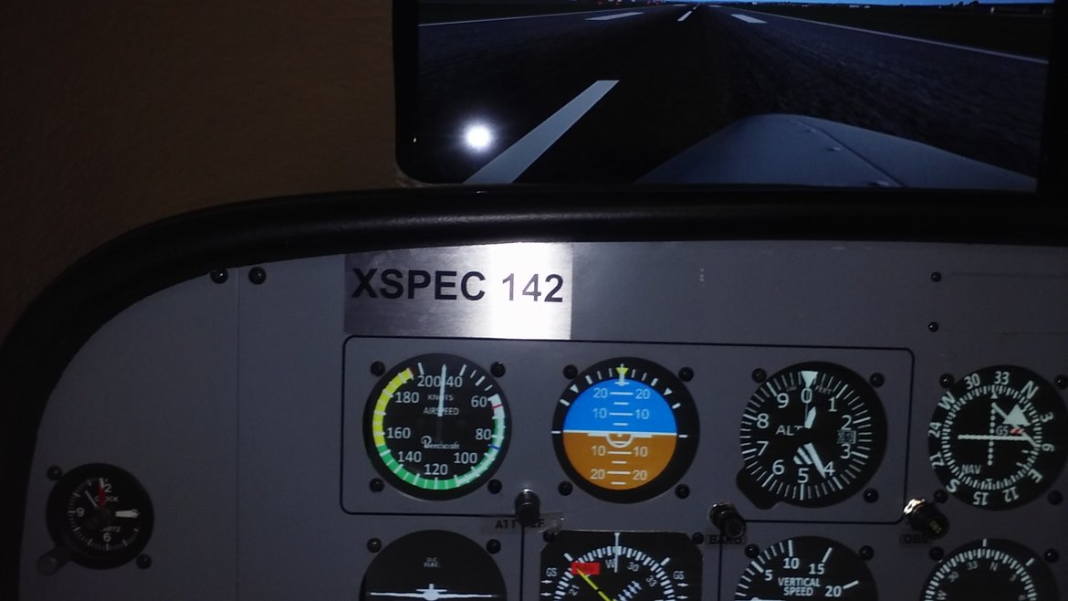
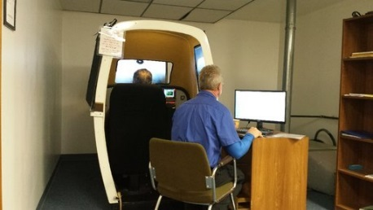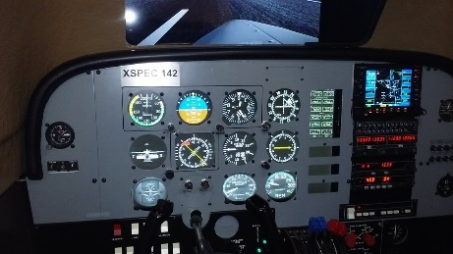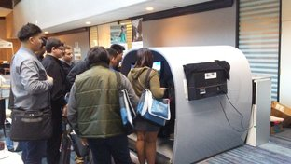
Our flagship device, the “XSPEC 142” is a single / multi-engine trainer that is an Advanced Aviation Training Device.
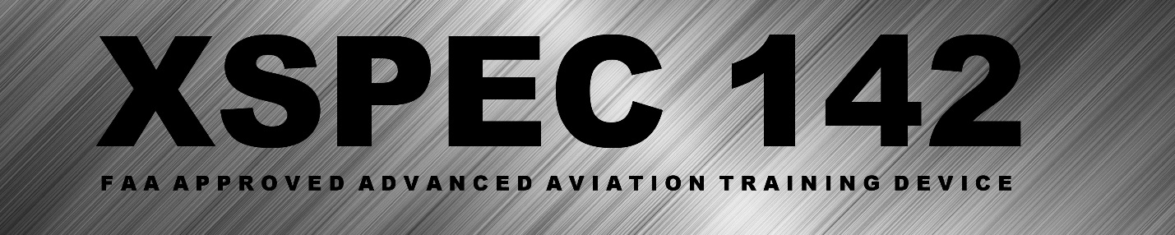
This FAA Approved training device will be approved until 2021, as it has just received new approval from the FAA. 2-Year Limited Parts Warranty is standard; while Lifetime-Internet Support is standard on every XSPEC Aviation Simulator- this is under our XSPEC Member Services Program.

XSPEC 142 (MEL-SEL AATD) BE76 – PA23 – C172RG – C172N
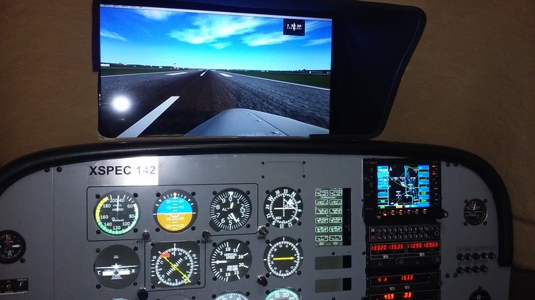
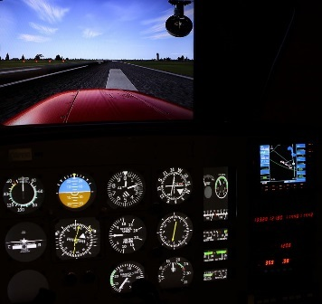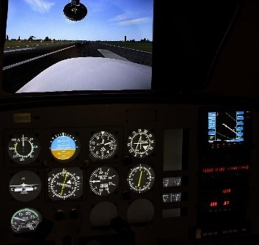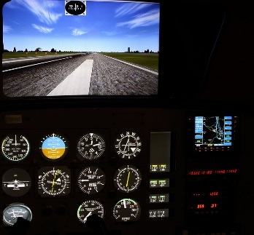
XSPEC Aviation is engaged in the Aviation community, and we embrace safety in our training devices- which is why we’ve reached for and achieved the prestigious AATD Approval from the FAA in our XSPEC 142.
We offer flight schools and universities a chance to own advanced, effective training devices at a fraction of the investment that is required by other AATD manufacturers. Because of our commitment to flight training, we have been accepted as a Member of the Flight School Association of North America.
“Founder” Member 2017
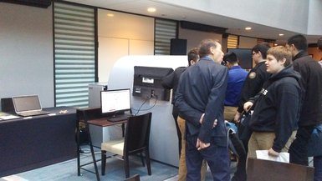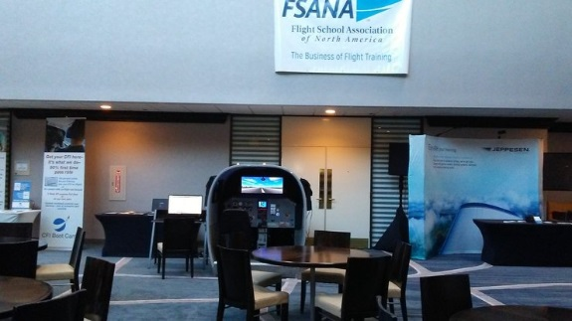
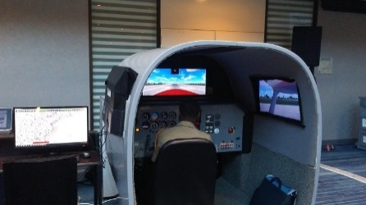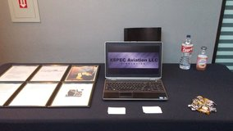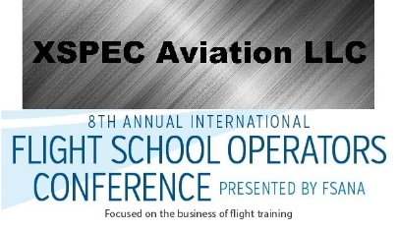
XSPEC Aviation is comprised of an effective, family team of two that have been leading the way in flight simulation re-manufacturing since Day 1.

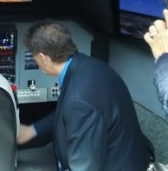 William Hill Jr. (Founder / Hardware Engineer)
William Hill has an extensive FAA 8130 Avionics repair history at the leading Avionics repair shops in America (IFR, Collins, Cessna) He designs, engineers and installs all the hardware components of our XSPEC simulators and has limited ANP experience. His lifetime of technical expertise and rich people skills have been the embodiment of our ethos at XSPEC Aviation.

Aaron Hill (President / Software Engineer)
Aaron Hill is the son of William Hill, and has grown up in the Aviation community. An award-winning programmer (2006 Programming Challenge University of Memphis) who prefers to write in-house software when advantageous; always gets the job done. His ingenuity, resourcefulness and determination have been key to securing the success of XSPEC Aviation on a technical level.

XSPEC Aviation has partnered with leading flight simulation companies and schools like Lockheed Martin, Flight1 Tech and ELITE Simulations to bring you a training device that truly rivals any other simulator on the market today.

Custom Solutions that maximize immersion and simulation effectiveness. We ‘make’ our gauges in house, we do all our own interfacing and only use 3rd party solutions when it’s the best approach for accuracy- not cost.
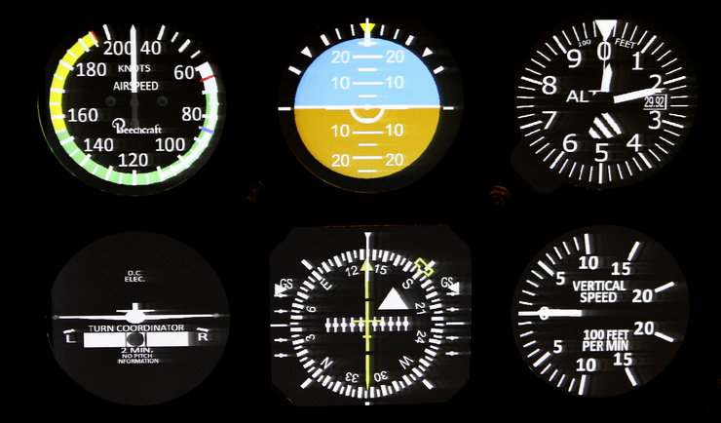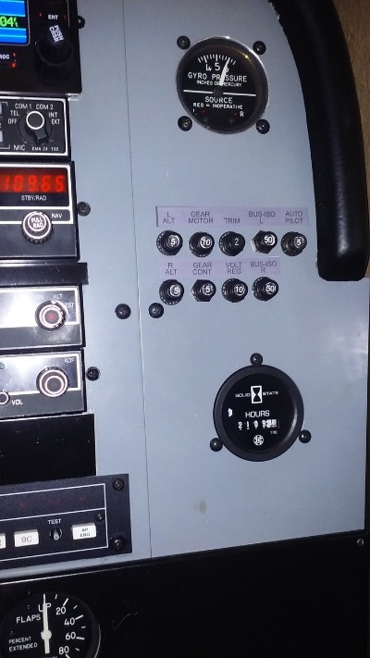
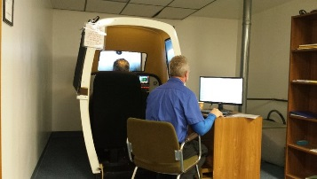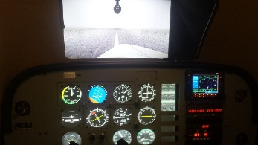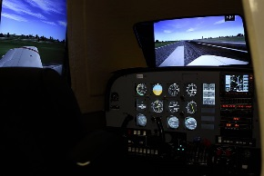

Having been tested and qualified by the Federal Aviation Administration (FAA) as an Advanced Aviation Training Device (AATD), you can be sure that all necessary systems were emulated- and that no shortcuts have been made on training quality and accuracy. Don’t purchase negative training, secure a proper investment in your flight school and safety.
XSPEC Aviation Models / Pricing:
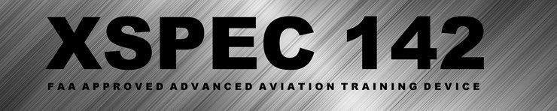
$46,800 (or) $41,800 with core trade in*
(4) AIRCRAFT CONFIGURATIONS
-BEECHCRAFT DUCHESS BE-76 -PIPER AZTEC PA-23
-CESSNA 172RG II "CUTLASS" -CESSNA 172N "SKYHAWK"

NEAR 1:1 G530 AWT EMULATION (GARMIN GPS530 AWT) (WAAS-LAAS-STARS)
AUTOPILOT / FLIGHT DIRECTOR / KFC 150
SILVERCROWN RADIO STACK / KX 165 - KT79 - KX87 - KMA24
WORKING CIRCUIT BREAKER FAILURE SYSTEM FOR TRAINING EMERGENCY SCENARIOS
ACCURATE, PLANE SPECIFIC INSTRUMENTS REMASTERED IN HIGH QUALITY 3D RENDERING
BUILT WITH / TESTED BY MULTIPLE CFI , CFII & MEI PILOTS / OWNERS
HIGH QUALITY AUDIO, VISUALS AND CONTROLS FOR REALISTIC AND ACCESSIBLE TRAINING
WORLDWIDE UP-TO-DATE JEPPESEN DATABASE FOR ACCURATE TRAINING
ELECTRIC PITCH TRIM - RUDDER TRIM - CONTROL SURFACES RE-MANUFACTURED TO NEW
(3) THREE WRAP-AROUND HD 1080P LCD LED MONITORS FOR VFR APPROACHES / INCREASED IMMERSION
COMPETITIVELY PRICED FOR FAST ROI (return of investment)
TWO (2) YEAR LIMITED WARRANTY (Parts / Labor)
BUILT TO LAST - COMPLETELY UPGRADED - LIFETIME INTERNET SUPPORT
INCLUDES LIFETIME XSPEC MEMBER SERVICE
EXCELLENT CUSTOMER SERVICE / FAMILY OWNED & OPERATED / GUARANTEED SUPPORT
FAA APPROVED ADVANCED AVIATION TRAINING DEVICE -(CLICK TO VIEW LOA)-

XSPEC 141* – $43,800
XSPEC 132* – $39,800
XSPEC 131* - $36,800
*Pending FAA AATD Approval. Coming Soon!
XSPEC Aviation builds training devices on time-tested highly popular platforms. Offering high quality devices at a fraction of the cost of the competition.

XSPEC Aviation is the leader in re-manufacturing pre-2008 flight training devices (AST / FRASCA). We are the first FAA Approved Simulator Remanufacturer.

All our AATD (Advanced Aviation Training Devices) are built with four (4) aircraft pre-loaded.

BEECHCRAFT BE-76 “Duchess”
-A light popular twin engine trainer aircraft
AZTEC PA-23 “Aztec”
-A more powerful twin engine aircraft for charter
CESSNA C172RG II “Cutlass”
-A popular single engine complex training aircraft
CESSNA C172N “Skyhawk”
-The most popular aircraft ever, a non-complex single engine aircraft.

We can offer this 4 aircraft configuration at a much lower price point than the competition, without the need for hardware swapping.
We’re working on expanding our LOA to include more aircraft for the same price! Even more value for your investment coming soon!
xspecaviation.com/files/documents/XSPEC-Aviation-Development-Release-PlaneList.docx
(Copy that link into your browser to learn about the aircraft coming)
Price Comparison: XSPEC vs Low Priced Industry Standard
XSPEC 142 AATD - $46,800

Competition Quote:
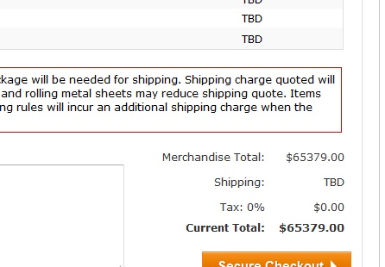
$65,379.00

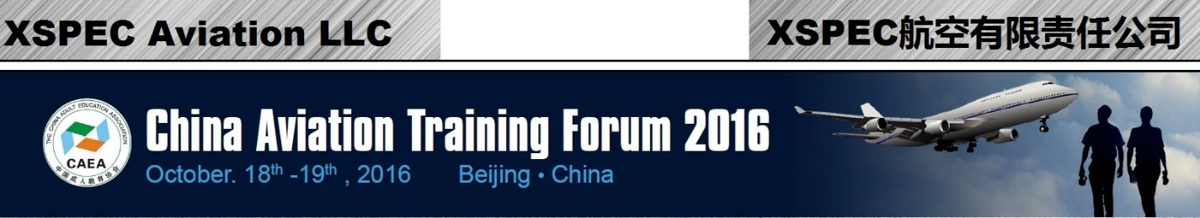
XSPEC Aviation is a global company; that can service flight schools all around the world. We were represented at CATF 2016- and are excited to help China’s ‘5 Year Plan’ for Aviation growth in China.
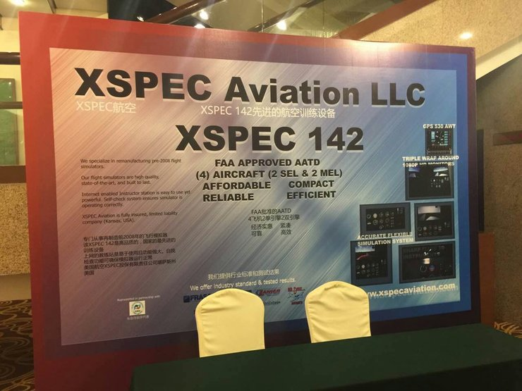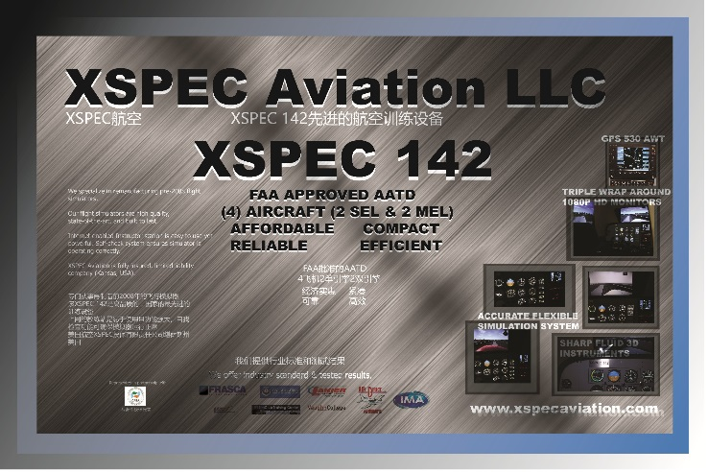
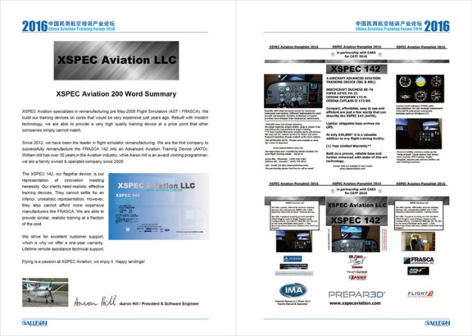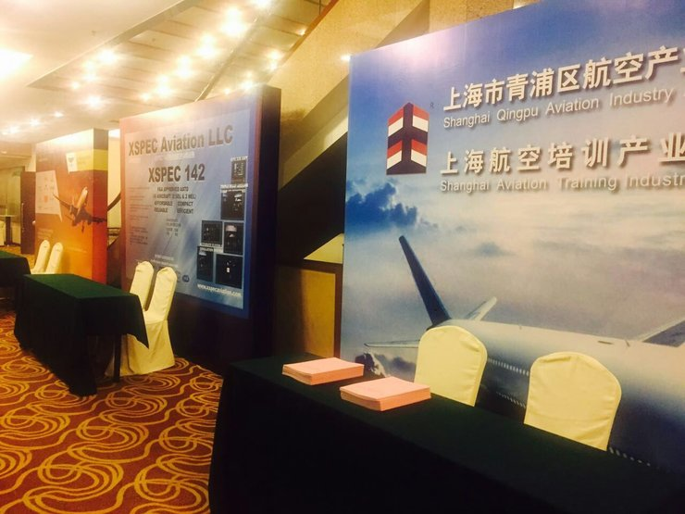

XSPEC Aviation Member Services Program
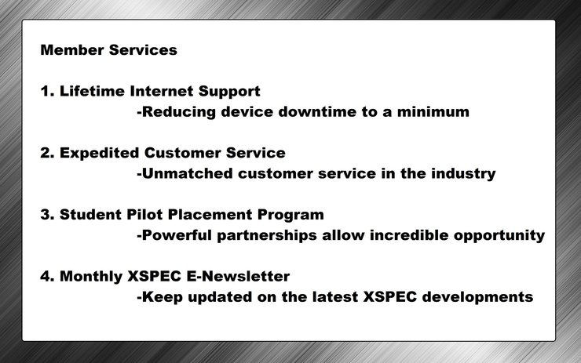
We have made a Cooperation Contract with HNA Group to provide qualifying flight schools with foreign student placement opportunities!
XSPEC Aviation strives to put its clients first.
Our service, when necessary is unmatched. We’re a family-owned corporation, and we don’t place profits first. Talk to us, get to know that we’ll work with you and accommodate any requests that are reasonable- whether they are technical, financial or otherwise.
We are a family at XSPEC Aviation and invite you to join!

XSPEC Aviation Financing Program

We have partnered with Calaway Capital Resources to bring you financing on our XSPEC 142. We work to find the best lenders to get you a convenient, competitive loan on your XSPEC 142 investment.
Even after finance costs, you’ll find your XSPEC 142 to still be cheaper than any other option on the market. We will work with you to meet your financial needs. We know that having a flight simulator is essential to any serious flight school.
Please contact us for more information and rates. We offer 36-month and 50-month finance options with no down payment*
*Requires collateral; usually an airplane works fine.

We have collectively over 50 years experience in the technical and aviation field. We offer consulting on nearly every topic related to the business, and if we don’t we can refer you to the ‘right person’.

Don’t purchase a flight simulator from a company that puts profits first, or will only visit your school once a year when needed. We are a family, and we believe that families help each other. We have been helping the industry for over 5 years, and we plan on growing even more than we have. We look forward to your business, and growing together.

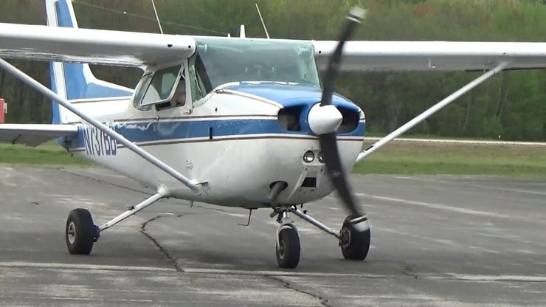

Feel free to contact us; we're always looking to meet new clients and industry professionals!
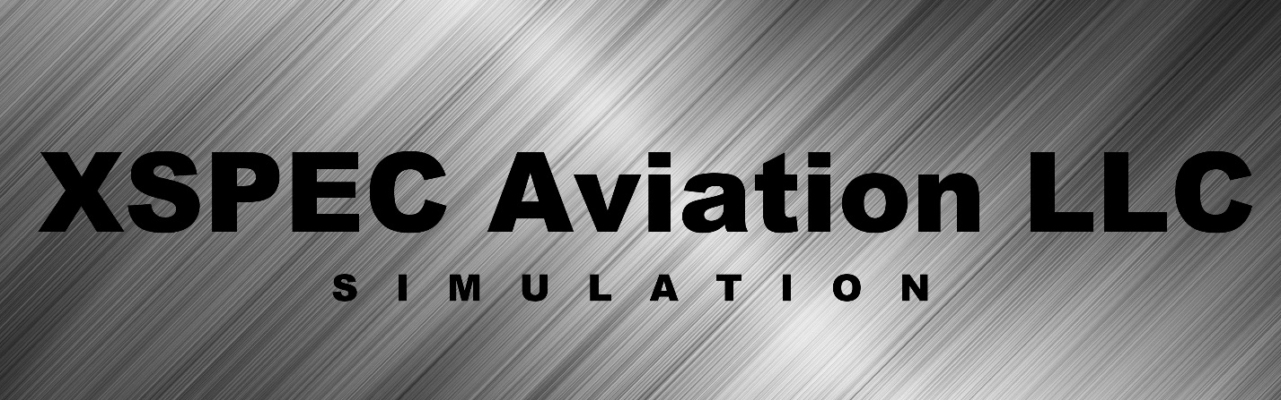
http://xspecaviation.com/contact
Aaron J. Hill
President
Software Engineer
Email: alanca03@live.com
ahill@xspecaviation.com
Cell: +1 (479) 418-2184
William J. Hill Jr.
whill@xspecaviation.com
Founder
Hardware Engineer
Email: whill@xspecaviation.com
Cell: +1 (479) 715-9514

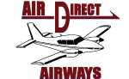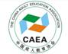
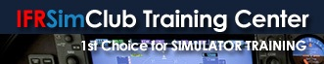

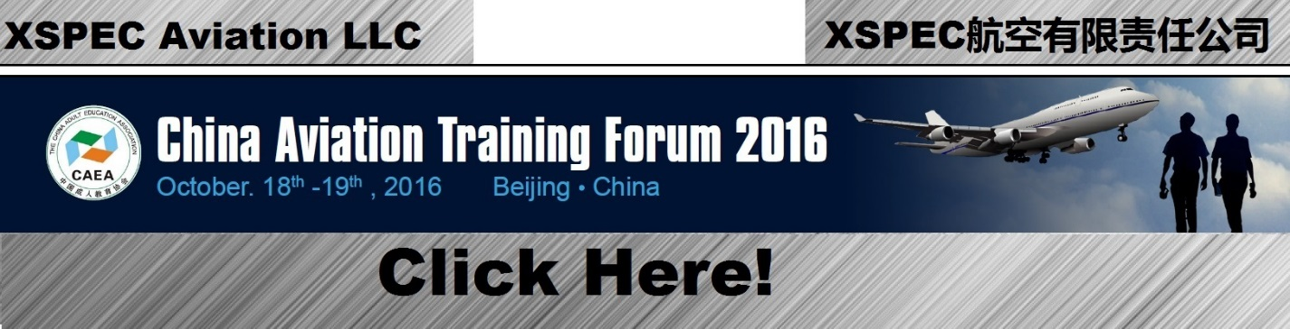

© 2017 XSPEC Aviation LLC
www.xspecaviation.com
6/19/17

